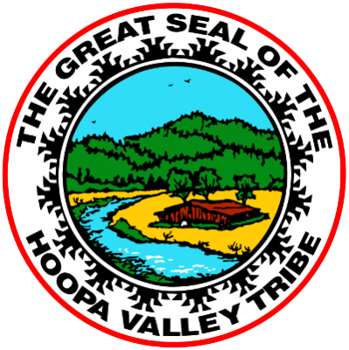
August 05, 2026
Linnea Jackson
Hoopa Valley Public Utilities District
(530) 625-4543 | gm@hoopavalleypud.com
acornconnected.com

FOR IMMEDIATE RELEASE
Hoopa TRAIL Project Will Bring Local Fiber-Optic Internet Service to Portions of Willow Creek and Trinity County

Hoopa, California — For residents and businesses in portions of Willow Creek and Trinity County, reliable high-speed internet service will soon come with something many rural communities do not have: a local provider with a direct connection to the people it serves.

Through the Hoopa Trinity Rural Access Linkup Initiative (TRAIL) Project, the Hoopa Valley Public Utilities District (HVPUD) is expanding fiber-optic broadband service into portions of Willow Creek and Trinity County. As construction progresses and service becomes available, eligible homes, businesses, and community institutions within the project footprint will be able to sign up for future service through Acorn Connected, the communications and technology division of HVPUD.

For the communities included in the project, stronger internet access can support everyday needs such as telehealth, education, remote work, emergency services, public safety communications, business operations, and access to other essential online resources. HVPUD is investing in these communities who have remained unserved for far too long.

“Our people have called this valley home for millennia, so our commitment to this region goes far deeper than just providing a service—we are deeply invested in our collective future,” said Linnea Jackson, General Manager of the Hoopa Valley Public Utilities District. “We are proud to deliver reliable, professional internet backed by a dedicated local team. When you need support, you aren't calling a distant call center; you’re reaching neighbors who are genuinely responsive and care about keeping our community connected.”

Acorn Connected is a locally operated, Tribally owned internet provider, and that local connection is central to how Acorn Connected approaches service. Its team lives and works in the region, understands the challenges rural communities face, and is committed to providing responsive support when problems arise. Through Acorn Connected, HVPUD is expanding broadband infrastructure into the Hoopa Valley Tribe’s ancestral territory.

The Hoopa TRAIL Project will build infrastructure to provide high-speed internet to connect unserved and underserved communities in Humboldt and Trinity counties. HVPUD plans to offer internet speeds of up to 1 Gigabit per second, with custom 10 Gigabit-per-second connections available upon request.

HVPUD is currently completing project design, surveys, and permitting, with this work expected to continue through summer 2026. Construction is anticipated to begin in early 2027 and is estimated to be completed by December 2027. Where feasible, construction will follow existing roads, public rights-of-way, utility routes, and available underground infrastructure to reduce disruption. This phase will serve only eligible properties within the funded project area in Trinity County and portions of Willow Creek and Douglas City.

This project is made possible through funding from the California Public Utilities Commission’s Last Mile Federal Funding Account Program, part of California’s broader effort to expand broadband infrastructure in areas that do not yet have reliable service.

Residents and businesses in Willow Creek and Trinity County are encouraged to check whether their location is included in the Hoopa TRAIL Project and sign up to receive service updates. To check availability or sign up for future service, visit acornconnected.com/hoopa-trail-project/ or contact Acorn Connected at (530) 625-4543.

About Hoopa Valley Public Utilities District
The Hoopa Valley Public Utilities District (HVPUD) is a duly chartered entity of the Hoopa
Valley Tribe and has been a trusted provider of essential utility services to the Hoopa Valley
Indian Reservation for over 44 years. Founded in 1982 under the authority of the Hoopa Valley
Tribe's Constitution and By-Laws, HVPUD is committed to supporting the tribe’s long-term
growth and economic vitality. In recent years, HVPUD expanded its services to include
high-speed internet through Acorn Connected, a broadband division dedicated to closing the digital divide and enhancing connectivity for residents and businesses in the region.

The mission of the Hoopa Valley Public Utilities District is to provide a level of service and
utility resources that enable and advance tribal strategies to grow economic opportunity, build a
strong foundation of utility infrastructure, and ensure a framework for quality growth and
development on the Hoopa Valley Indian Reservation.

###

